**Scenario: Launch expired_page**

**Step: Launch "expired_page" WebPage - PASS**

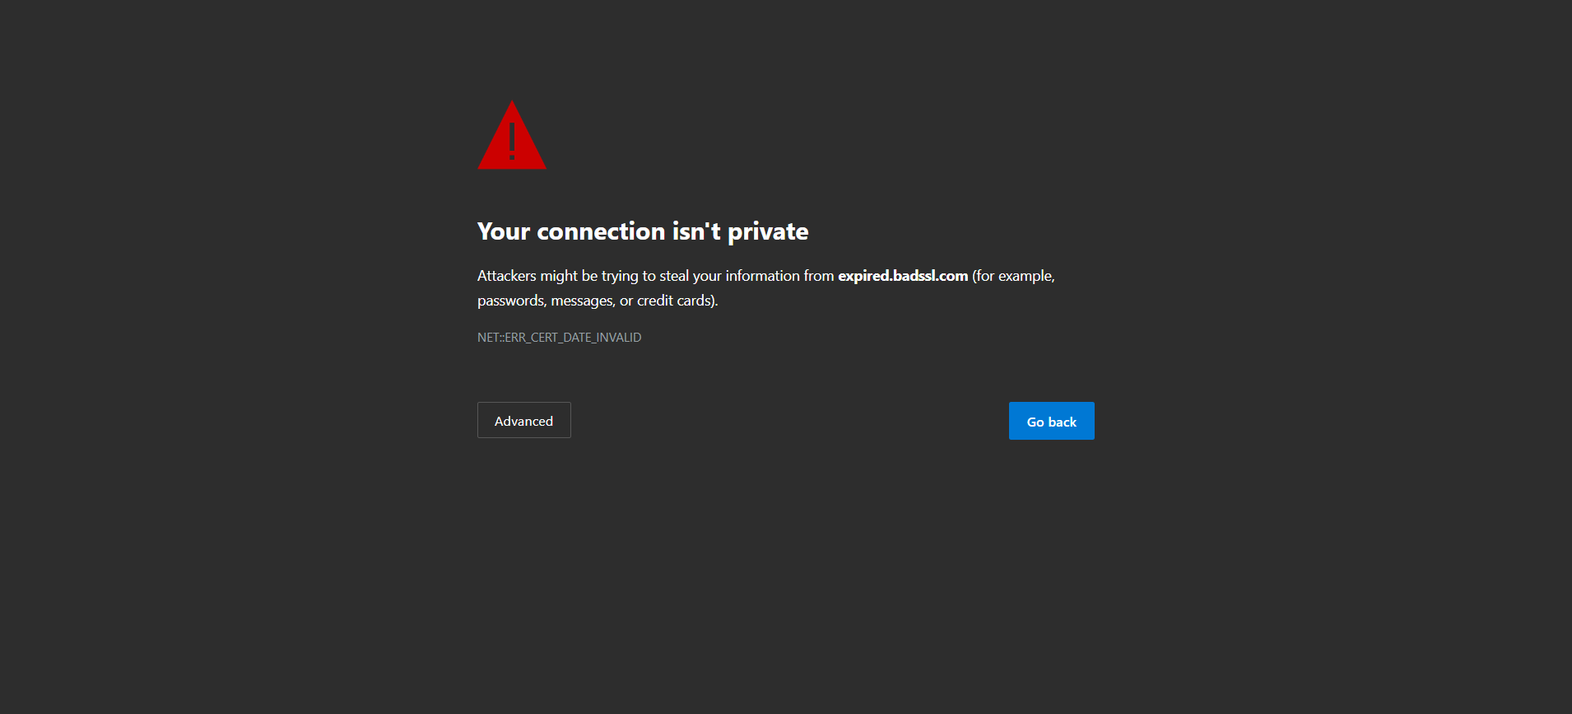

**Step: And the user waits for "10" seconds - PASS**



**Execution Summary:  
Total Steps: 2  
Passed: 2  
Failed: 0**